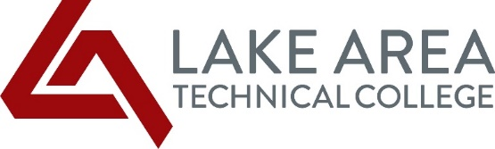
LATC Students, October 21, 2021

As a Lake Area Tech student, you are receiving a HEERF III Emergency Student Grant. This funding was authorized by Congress as part of the American Rescue Plan and is intended to help defray costs and hardships you have incurred due to the COVID pandemic. This is a grant and does not have to be repaid. It does not count as part of your financial aid package. This is the final disbursement of Emergency Student Grant funding that will be made to students. We did not deduct from the grant award any outstanding Tuition and Fees or other charges that you may still owe LATC.

How did Lake Area Tech determine the HEERF III awards for fall semester? The funds were to be prioritized for high need students. We reviewed students who were enrolled as of October 15, 2021. Our funding model consisted of the following criteria:

CATEGORIES OF STUDENTS ENROLLED FALL 2021 | AWARD AMOUNT
Students Enrolled at Least Half-Time (6 or more credits)
Pell Grant Eligible | $1,750
Non-Pell Grant Eligible (This included those students who did not complete a 20-21 FAFSA.) | $1,150
Students Enrolled Less-Than-Half-Time (less than 6 credits)
Pell Grant Eligible | $ 750
Non-Pell Grant Eligible (This included those students who did not complete a 20-21 FAFSA.) | $ 500

We realize that many individuals have been impacted by the pandemic. If you filed a 2021-2022 FAFSA (Free Application for Federal Student Aid) and have had a change in your family’s income or have had other situations related to the pandemic, please contact the Financial Aid Office to inquire about a possible reduction in income adjustment.

If you have specific questions about the HEERF III Emergency Student Grant, please do not hesitate to contact one of the following Financial Aid Office staff: Carrie Jordanger (Ext. 254) or Marlene Seeklander (Ext. 255).

It’s been over a year since we started dealing with the COVID pandemic. I couldn’t be more proud of how all of you have handled the past year. Please do not hesitate to reach out to any of the staff or faculty if you need anything.

Sincerely,
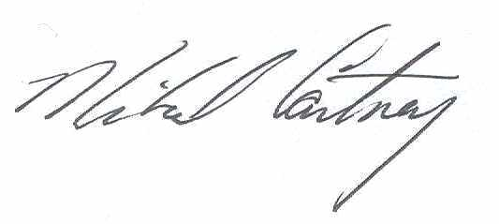
Mike Cartney
President

