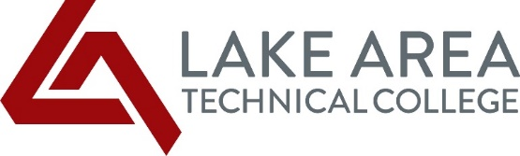
LATC Students, October 27, 2021

As a Lake Area Tech Dual Credit student, you are receiving a HEERF III Emergency Student Grant. This funding was authorized by Congress as part of the American Rescue Plan and is intended to help defray costs and hardships you have incurred due to the COVID pandemic. This is a grant and does not have to be repaid. This is the final disbursement of Emergency Student Grant funding that will be made to students. We did not deduct from the grant award any outstanding Tuition and Fees or other charges that you may still owe LATC.

How did Lake Area Tech determine the HEERF III awards for fall semester? High School students taking Dual Credit classes are also eligible for an award to help defray expenses associated with the pandemic. We reviewed students who were enrolled as of October 15, 2021. Our funding model consisted of the following criteria for Dual Credit students:

CATEGORIES OF STUDENTS ENROLLED FALL 2021 | AWARD AMOUNT
Dual Credit Students (High School students taking college credits)
Enrolled in 1 credit | $ 12
Enrolled in 3 credits | $ 36
Enrolled in 4 credits | $ 48
Enrolled in 4.5 credits | $ 54
Enrolled in 6 credits | $ 72
Enrolled in 9 credits | $109
Enrolled in 10 credits | $121
Enrolled in 12 credits | $145
Enrolled in 15.5 credits | $187
Enrolled in 22 credits | $266

If you have specific questions about the HEERF III Emergency Student Grant, please do not hesitate to contact one of the following Financial Aid Office staff: Carrie Jordanger (Ext. 254) or Marlene Seeklander (Ext. 255).

It’s been over a year since we started dealing with the COVID pandemic. I couldn’t be more proud of how all of you have handled the past year. Please do not hesitate to reach out to any of the staff or faculty if you need anything.

Sincerely,
Mike Cartney
President

